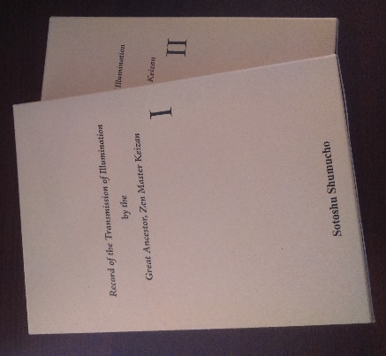
Denkōroku
Record of the Transmission of Illumination

by the Great Ancestor, Zen Master Keizan
Volume 1: English translation (582 pages)
Volume 2: Introduction, Front matter, Glossary, Bibliography (728 pages)

The Denkōroku (Record of the Transmission of Illumination), together with Dogen Zenji's Shobogenzo (Treasury of the True Dharma Eye), is one of the fundamental texts of the Soto School. It is an exceptional record of the Zen ancestors that begins with Sakyamuni Buddha, extends through twenty-eight generations in India and twenty-three generations in China, and reaches to Dogen Zenji and Ejo Zenji. It provides instruction, in teisho format, about the causes and conditions whereby each awakened to the Way that was individually transmitted by the one Buddha and fifty-two ancestors.

Purchase order
Your name (First name, Surname):
Address (number and street):
Supplemental information (floor, room number etc):
City:
Postal code:
Country:
Telephone number:
Email:
Number of order:

We will send by Colissimo (Courier service of French Post)
The price is 135.00EUR + Postal fees from Paris
Please send this sheet by email to info@sotozen.eu

